**[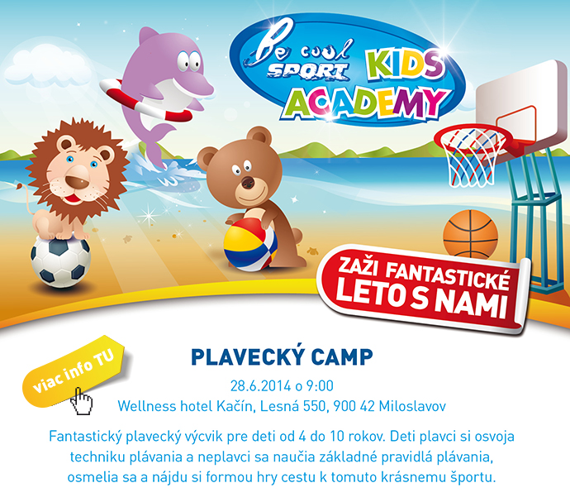](http://sportkidsacademy.sk/index.php?id=2&tx_ttnews%5btt_news%5d=12)**